AOI Viewer tutorial
- What is AOI Viewer
In brief, AOI Viewer helps auto-picking AOIs and mapping, enable the following intensity and FRET calculation.
- How to use AOI Viewer
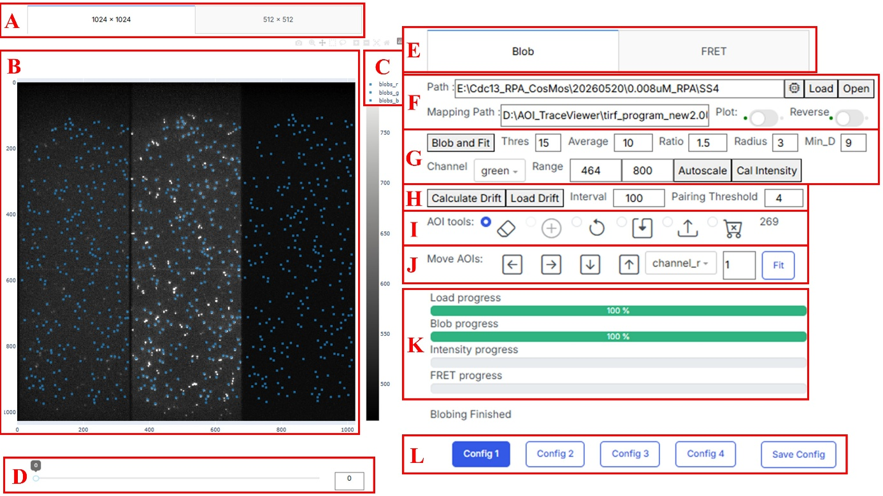
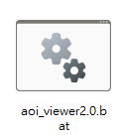
- To use the AOI viewer, double-click the aoi_viewer2.0.bat file on your Desktop. A webpage and a command prompt (cmd) window will open. Wait until the command prompt displays a rocket icon, then press F5 to refresh the webpage.
- Select the image size of the video you want to analyze by adjusting the tab A setting. (Options are usually 512x512 or 1024x1024).
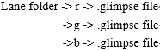
- Copy the folder path of your video file and paste it into the Path field in F. Ensure the folder you select contains sub-folders named "r", "g", or "b" that include .glimpse files. Click Load and wait for the Load progress bar in G to complete.
- Your snapshot will appear in B (AOIs will not be visible yet). From left to right, the regions represent the red, green, and blue receiving channels. You can adjust the desired frame in D. If you prefer a white background with black data points, turn on the Reverse toggle in F.
- Before auto-picking AOIs, set the following parameters in G:
- Thres (Threshold): Sets the spot-selection criteria. AOIs below this threshold are excluded. Increase this value if too much non-signal background is selected (usually 7 for 512x512, and 15 for 1024x1024).
- Average: The number of frames averaged to fit the AOI positions. 10 frames are recommended.
- Ratio: Sets the criterion for spot shape using Otsu and skimage algorithms. If the blob's major axis divided by its minor axis is greater than this ratio, the spot is excluded.
- Radius: The size of the AOIs. 3 is recommended.
- Min_D: The minimum allowable distance between blobs. If two blobs are closer than this value, both are excluded. 9 is recommended.
- Channel dropdown: Select the specific excitation video used to pick the blobs.
- Range: Adjusts the image contrast. Use the Autoscale button to set the minimum and maximum automatically, then manually adjust the maximum so the blobs are clearly visible without significant visual overflow.
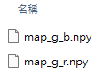
Important: Make sure the Mapping Path in F contains the correct mapping file, otherwise an error will occur. Once your parameters are set, click Blob and Fit and wait for the Blob progress bar in K to finish.

- Use the tools in I to remove bad AOIs. Select the eraser tool to delete them. The tools from left to right are: remove AOI, add new AOI (currently non-functional), undo previous action, save AOI data, load AOI data, and remove all AOIs. You can also hide or show the AOIs in specific regions by clicking label_{channel} in C.
- If you notice the channel AOIs have shifted relative to the actual signal dots, use the Move Aoi function in J to systematically move all AOIs in a specific channel. Click the Fit button afterward to snap them to their best locations.
- Click Cal intensity to calculate the intensity of the AOIs and wait for the Intensity progress bar in K to finish. If you click Open in F, you will see that two new folders (circled and raw) and two new files (blobs.npz and dcombined_image.npy) have been added to your directory.
- If the signal slowly departs from the initial blob over time, use the Calculate drift function in H. Set the Interval (frames per calculation) and Pairing Threshold (maximum distance for centers to be considered the same point).
Clicking Calculate Drift will auto-pick and pair AOIs per interval to calculate average displacement, calibrating all frames back to the window to correct the drift. This creates a drifts folder. You can use Load Drift to apply these previous calibration results later.

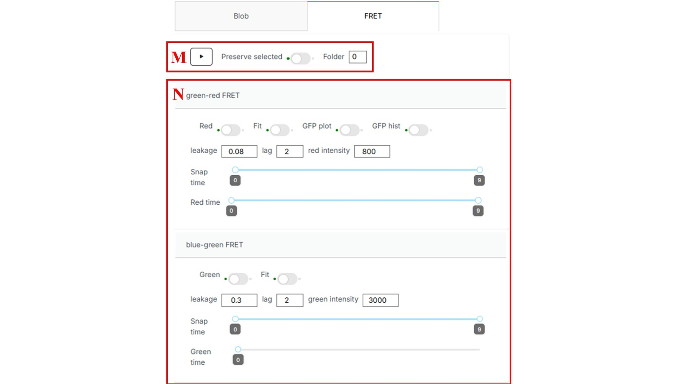
- Navigate to the FRET tab at the top of E.
- If you already have selected_g and selected_b annotations that you want to keep, turn on the Preserve selected toggle in M. If left off, old annotations will be overwritten.
- To preserve older FRET calculations, change the Folder input number in M (for example, change "0" to another number). This creates a new, separate folder to store the new FRET values.
- Note which FRET configuration you are using (e.g., open green-receive red, or open blue-receive green) and configure the following in N:
- Fit toggle: Select the FRET type you want to fit the histogram with (blue-to-green, green-to-red, or both).
- Red/Green toggle: Filters out dead acceptor dyes (like Cy3'/Cy5'). If an AOI's intensity falls below this threshold, it is excluded and its value becomes -1.
- Leakage: The beta constant used in the calculation. This calibrates the leakage of donor dye intensity into the acceptor channel and must be determined using donor-only substrates.
- Lag: The number of averaged smoothing frames used in histogram plotting.
- Snap time & Red/Green time: Determines how many frames are used to calculate FRET and filter out dead spots.
- GFP plot toggle: If enabled, the GFP intensity/FRET heat map will be saved to the root path after calculation.
- GFP hist toggle: If enabled, the GFP intensity histogram will be saved to the root path after calculation.
- Once all settings are configured, press the Play icon button in M.

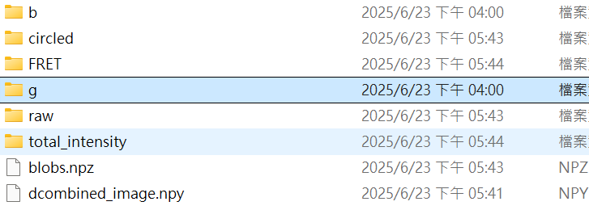
- When the calculation finishes, two new folders will be added:
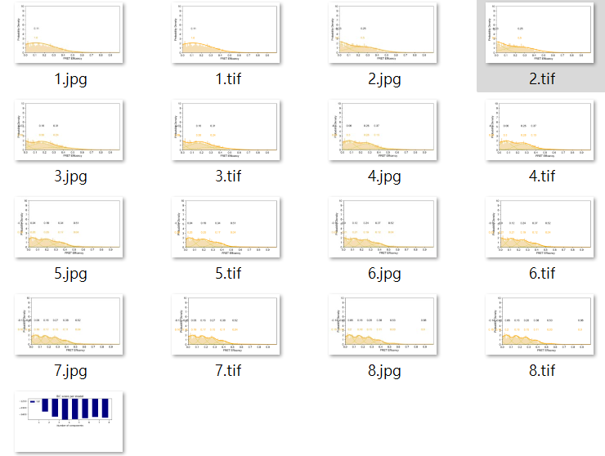
- FRET: Contains the distribution graphs of FRET efficiency (e.g., located in FRET\0\b).
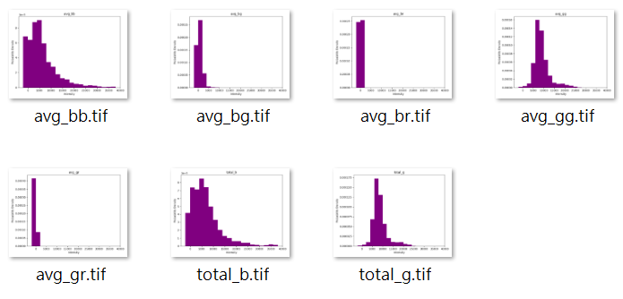
- total_intensity: Contains the distribution graphs of the AOIs' intensities.
- If you want to keep these exact parameter settings for your next analysis, click Save Config in H.

Trace Viewer tutorial
- What is TraceViewer
In brief, TraceViewer helps user view the data.npz file output by Aoi viewer. This software also contain breakpoint annotation, rupture detection, gaussian mixture, hmm fitting and blob visualization.
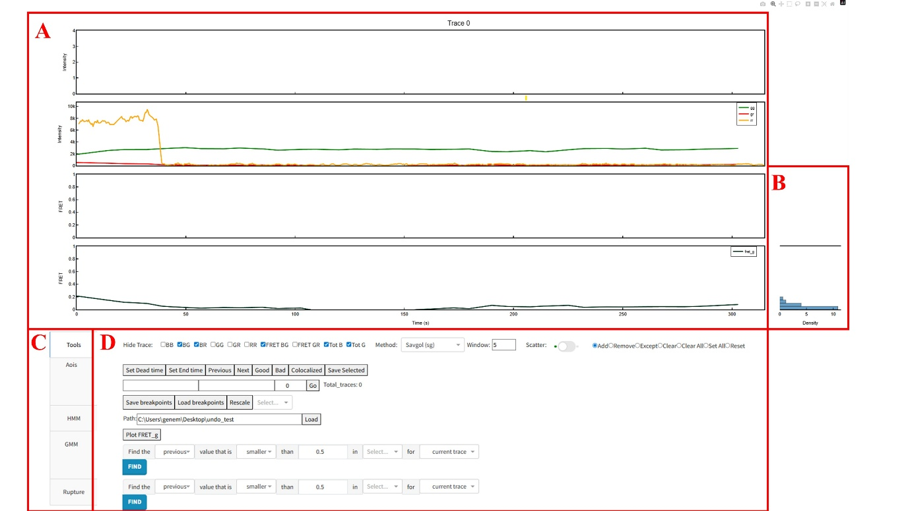
- How to use Trace Viewer

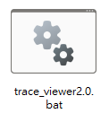
- To use the Trace Viewer, click the trace_viewer2.0.bat file on your Desktop. A webpage and a command prompt (cmd) window will open. Wait for the rocket icon to appear in the cmd window, then press F5 to refresh the webpage.

- The Trace Viewer offers a variety of sophisticated custom analysis tools. The interface is divided into four main functional areas:
- A: The main graph displaying trace data from the specific data.npz file.
- Row 1: All "b" excitation traces (bb, bg, br).
- Row 2: All "g & r" excitation traces (gg, gr, rr).
- Row 3: The fret_b (b_g fret) trace data.
- Row 4: The fret_g (g_r fret) trace data.
- B: The FRET histogram (displays fret_b and fret_g only).
- C: The functional tabs. Switching between these tabs changes the tools available.
- D: The main workspace for each functional tab. The contents of D change depending on which tab is selected in C.

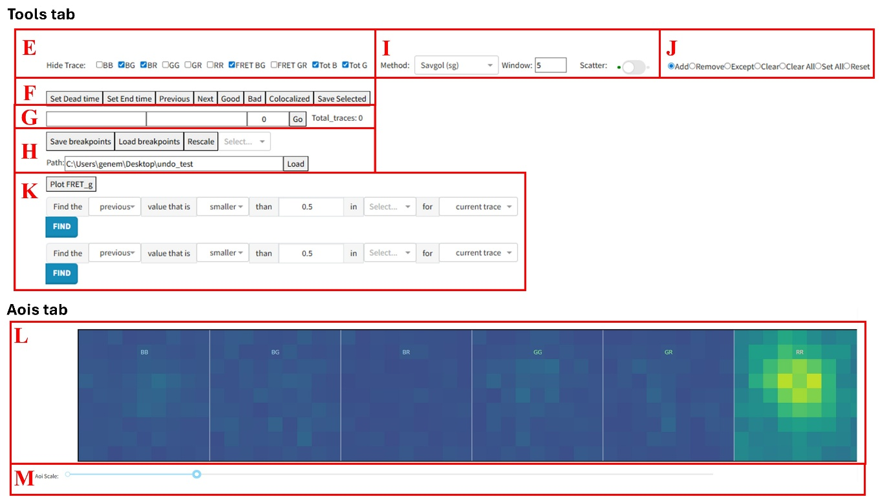
- After loading the main page, the Tools tab is set as the default (this is the most important part of the viewer). Paste your data.npz file path into H and press the Load button. The trace data will appear in A.
- Use the checkboxes in E to select which traces to show on the main graph (A). Tot_B represents the combined intensity of all 'b' excitations (bb + bg + br). Tot_G represents the combined intensity of 'g' excitations (gg + gr).
- In the data showing area (I), you can change the trace smoothing method using the Method dropdown. Window sizes can also be customized. The Scatter toggle hides the trace lines and shows only the data points. The four smoothing types are:
- Fix window average (Strided average)
- Sliding window average (Moving average)
- Sliding window median (Median)
- Sliding window Savgol (Savgol)
(Hint: if you need more understanding, view the smoothing.py in Trace_viewer\utils folder)
- To view a different molecule trace, use the Previous and Next buttons in F (or use the q and w keys on your keyboard) to cycle through the index numbers. Alternatively, type a specific index number into the input field in G and press Go to jump directly to that trace.
- You can annotate whether a trace is valid using the Good and Bad buttons in F (or the z and x keys). This maps to the selected_g.npz file: +1 (Good/Green), -1 (Bad/Red), or 0 (Unmarked/No color). Crucial: After reviewing and marking your traces, you must press the Save selected button in F to save your annotations.
- You can manually annotate breakpoints by clicking directly on the trace data. The red dot represents a breakpoint. Choose your interaction mode in J:
- Add: Places a new breakpoint where you click directly on trace.
- Remove: Deletes the existing breakpoint near your click.
- Except: Keeps only the closest breakpoint on that channel and deletes all others on the current trace.
- Clear: Wipes every breakpoint of the current channel on the current trace.
- Clear All: Wipes every channel's breakpoints on the current trace.
- Set All: Copies the current channel's breakpoints onto every other channel.
- Reset: Opens a confirmation dialog to wipe every breakpoint on every trace.
- Additional breakpoint tools in F:
- Set Dead time / Set End time: Appends a breakpoint at the very first or very last frame of the selected channel (chosen via the dropdown in H). This marks the active region without needing to click the trace.
- Colocalized: Toggles a separate colocalized flag for the current trace (saved alongside selected_g when you press Save Selected).
- Breakpoint file management in H:
- Save breakpoints: Writes all breakpoint data to breakpoints.npz (the previous file is backed up with a timestamp).
- Load breakpoints: Reloads breakpoints.npz into memory.
- Rescale: Resets the zoom into the full time range.
- Auto-detection is handled in K:
- Plot FRET_g: Batch-plots every trace's fret_g curve into PNG files for a dataset overview.
- Find (Rows 1 & 2): Automatically places a breakpoint where the smoothed signal crosses a threshold. You can specify the frame relative to the crossing (first, second, previous), the direction (bigger, smaller), the threshold value, the target channel, and the scope (current trace, all traces, or only 'good' traces). Press FIND to apply.
- Press Ctrl+Z to revert your last edit.
- On the Tools, Aois, and GMM tabs, it reverts breakpoint edits (Add/Remove, Set Dead/End, Clear/Set All, Auto-Find).
- On the HMM tab, it reverts state amendments (Boundary move, Delete, Add, Change state).
- Exceptions: The history depth is 5 steps. The Rupture tab does not support Ctrl+Z (use its Clear buttons). Good/Bad marking (z/x keys) is never affected by Ctrl+Z.
- Aois tab shows the average blob heat-map of every channel (BB, BG, BR, GG, GR, RR) for the current molecule in L. Hover over the cells to read per-pixel intensity. Use the AOI Scale slider in M to adjust contrast across all heat-maps.
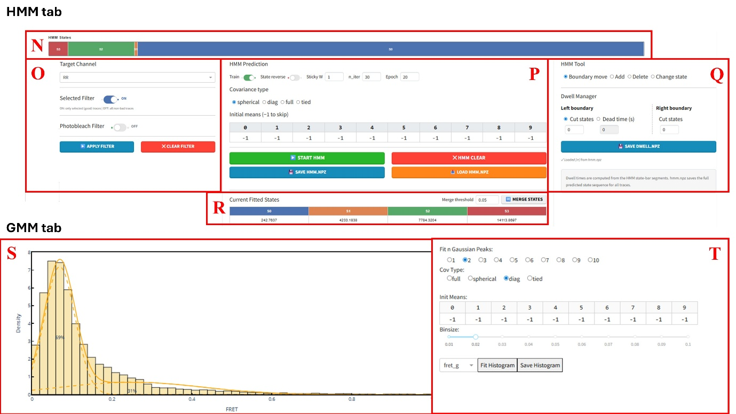
- HMM tab fits a Gaussian HMM on a selected channel. N is the State Bar above A, showing the per-frame state sequence of the molecule (each color represents a state). Edit the prediction by clicking the bar using the tools in Q.
- O sets the HMM data filters. Choose your target channel, apply the Selected Filter (only fits 'Good' traces), or apply the Photobleach Filter (truncates the fit at the photobleach frame based on intensity). Press APPLY FILTER before fitting, or CLEAR FILTER to remove it.
- P is the Prediction area. Set your parameters (Train toggle, State reverse, Sticky W bias, iterations, epochs, covariance type, and initial means). Press START HMM to fit. Use the Save/Load buttons to manage your hmm.npz prediction files and transition counts.
- Initial Means: Enter your estimated starting values left-to-right. The number of valid entries dictates the number of states (k). Leave unused cells as -1.
- Train toggle: Leave ON to run a fresh fit (saves a new model.pkl). Turn OFF to skip fitting and only predict traces using your last saved model.
- Sticky W: Controls state "stickiness." The default is 1. Increase to 1.5–3.0 if your fit produces too many rapid, 1-frame flickers.
- n_iter & Epoch: Set n_iter (iterations per fit) to 20–30 and Epoch (random restarts) to 10–20 for reliable convergence.
- Covariance type: Use tied if you believe all FRET states share the exact same detector noise level. If you fit with intensity data diag is the most recommend.
- State reverse: By default, S0 is the lowest signal state. Turn this ON to flip the sorting so S0 represents the highest signal.

- Q contains manual editing tools for the state sequence. You can snap boundaries to specific frames, add/delete segments, or re-assign states using digit keys.
- Boundary Move (Adjust a transition): Click the left or right half of a state segment on the state bar (N) to highlight its boundary (turns gold). Then, click the exact frame on the main trace(A) graph where the transition should actually occur to snap it into place.
- Add (Insert a missing state): Click near a boundary on the state bar to create a white "?" vacuum block. Press a number key (0 to k-1) to assign a state to this new segment.
- Delete (Remove an unwanted state): Click a segment to delete it. The gap will automatically be filled 50/50 by its neighboring states so no hole is left behind.
- Change State (Fix a label): Click an existing segment to turn the whole block into a white "?". Press a number key (0 to k-1) to assign it the correct state without altering its boundaries.
- The Dwell Manager in Q allows you to censor the first/last segments of each trace. Press SAVE DWELL.NPZ to record per-state dwell times.
- Left Boundary Mode (First Dwells): Choose how to handle the first unobserved transition.
- Cut states (Default): Discards the first N dwells entirely. Set the Left cut input to 1 to drop just the first incomplete dwell (most common), or 0 to keep everything.
- Dead time (s): Keeps the first dwell but adds a fixed amount of time to its duration. Use this if you know exactly how many seconds passed between the trigger and the actual start of acquisition.
- Right Boundary (Last Dwells): Handles the end of the trace.
- Visual Preview: Any state segment that you cut will instantly turn grey on the HMM state bar, allowing you to preview exactly what will be excluded from your final data.
- Save Dwell.npz: Applies your cuts, calculates the valid dwell durations in seconds, and saves them to dwell.npz.
- R displays the read-only Current Fitted States table (sorted means S0 to Sk-1) and the Merge States function.
- Merge threshold: sets the maximum absolute difference between two fitted state means for them to be considered the same state.
- Merge States button: after clicking, states whose means fall within the threshold are collapsed into one (averaged mean, remapped indices).
- GMM tab fits a Gaussian mixture to the selected FRET histogram. S displays the histogram with the fit overlaid. T sets the fit parameters (number of peaks, covariance type, initial means, bin size, and channel). Press Fit Histogram to calculate, and Save Histogram to export the figure and parameters.
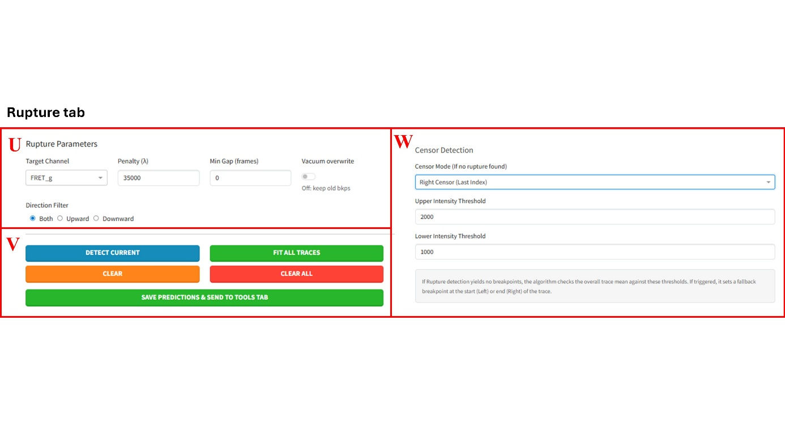
- Rupture tab uses Python's rupture library to detect change-points automatically. U sets the parameters (Target Channel, Penalty/λ, Minimum Gap, Vacuum overwrite, and Direction Filter).
- Penalty: Controls the sensitivity of the breakpoint detection. A higher penalty makes the algorithm more conservative, resulting in fewer breakpoints being detected.
- Minimum Gap: Sets the minimum allowed distance (in frames) between two adjacent breakpoints. If the algorithm detects two breakpoints closer than this gap, it will only keep the first one and discard the second.
- Vacuum Overwrite Toggle: Determines what happens when the algorithm finds zero breakpoints on a trace that already has previously saved breakpoints (from an older breakpoints.npz file).
- OFF (Default): The existing breakpoints for that trace are safely preserved.
- ON: The trace is wiped clean ("vacuumed"), completely erasing the old breakpoints and replacing them with the new empty result.
- Direction Filter: Rupture detects both upward and downward steps by default. This radio button allows you to filter the results so the algorithm only keeps Upward breakpoints, only Downward breakpoints, or Both.
- V is the action area. Click Detect Current to preview predicted breakpoints as purple dots on A. Fit All Traces applies this to the whole dataset with selected channel. Once satisfied, press Save Predictions & Send to Tools tab to convert the purple dots into real red breakpoints.
- W manages Censor Detection for traces where no breakpoints are found. You can set fallback breakpoints (Left Censor, Right Censor, or None) based on Upper/Lower intensity thresholds—highly useful for fast-photobleaching traces.

